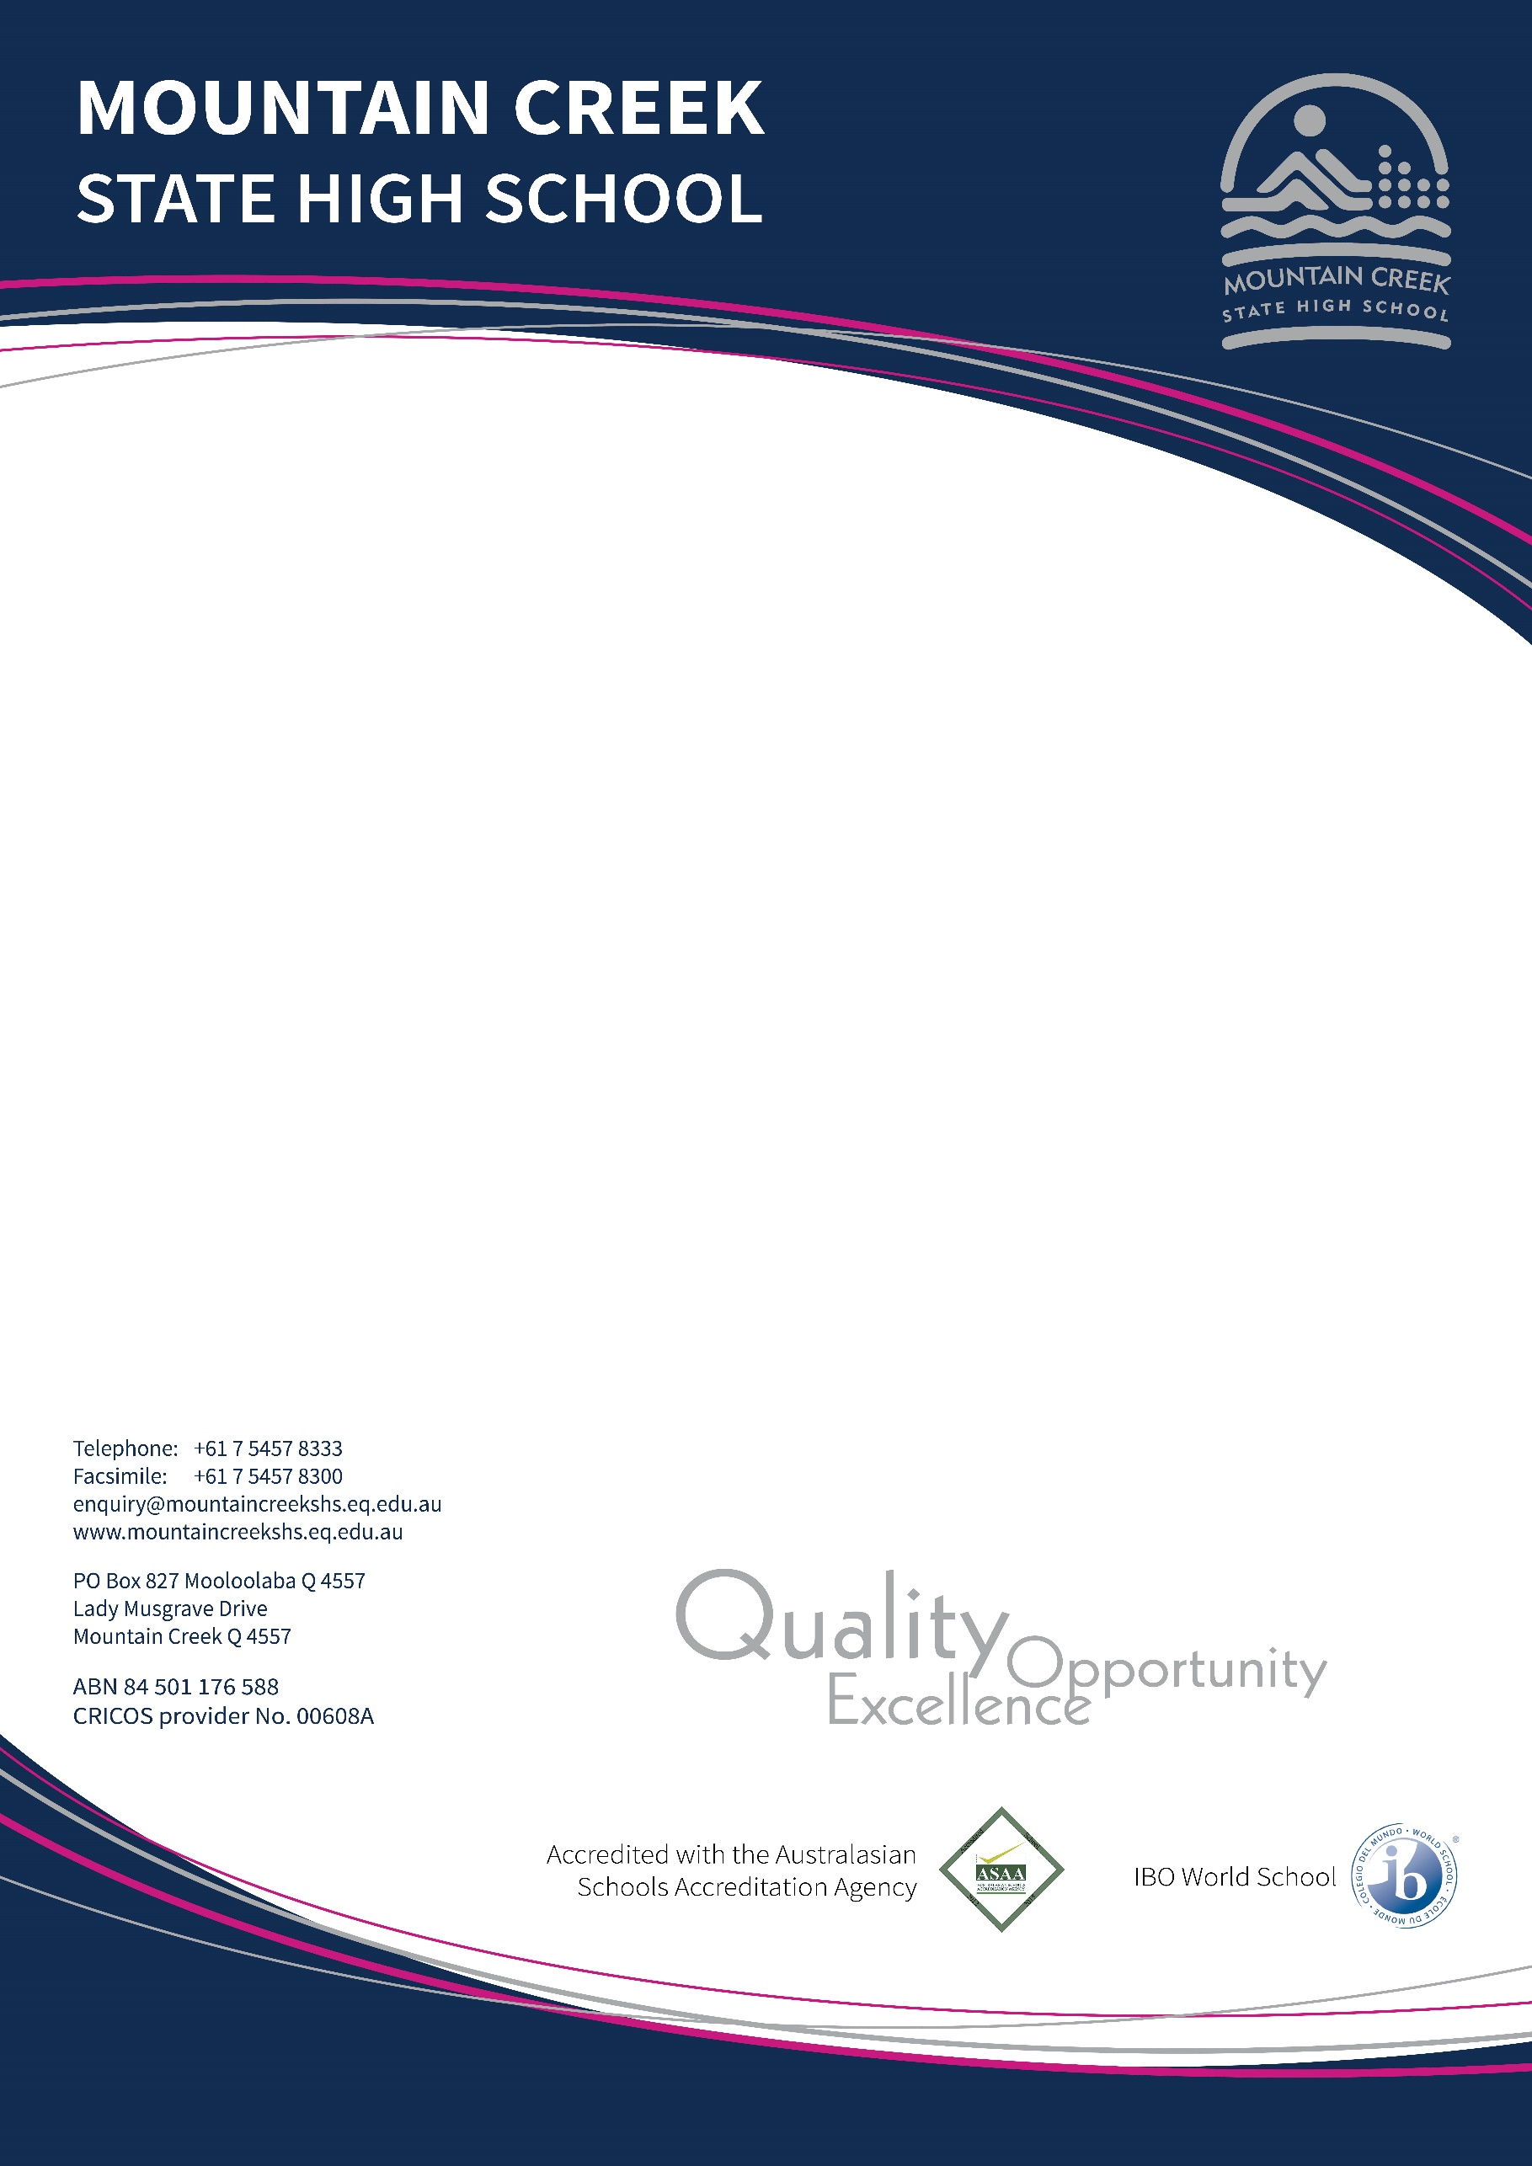
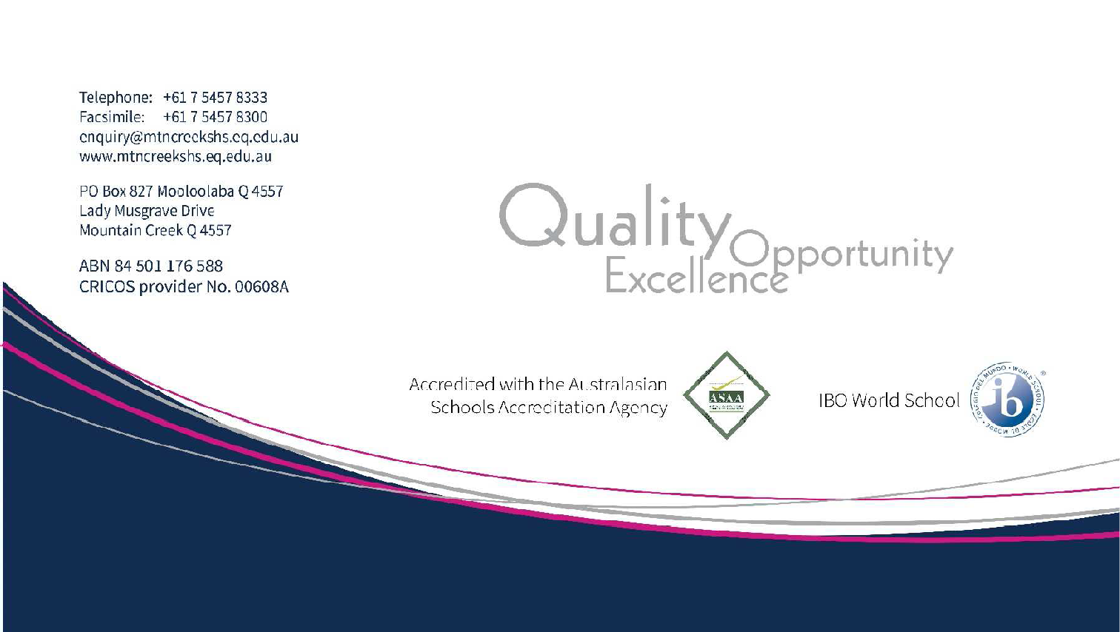

SCHOLARSHIP

INTERNATIONAL BACCALAUREATE
PROGRAMME

2021 APPLICATION PACKAGE for 2022

Year 10 (Preparatory), 11, 12 in 2022
STUDENT NAME:

YEAR LEVEL IN 2021:

Version 10.2021
Mountain Creek SHS P&C Association is offering scholarships to students entering the International Baccalaureate Diploma Programme as year 10, 11 or 12 students. The scholarship will be for one year only. The funding of this scholarship is to reward students who are performing to a high academic standard and embody the spirit of the International Baccalaureate Diploma Programme. The Scholarship will be used to offset the payment of IB Fees for that year.

Students applying for the scholarship must:

- Complete the attached application form.
- Be academically eligible to enroll in the International Baccalaureate Diploma Programme.
- Return the completed application form to:

IB Coordinator
Mountain Creek State High School
P.O. Box 827
MOOLOOLABA QLD 4557

- Closing Date: Friday, November 26, 2021 (end of Week 8).
- Winners of the scholarships will be announced at IB Graduation in February 2022. Successful applicants of the scholarship will be required to sign an acceptance form acknowledging the conditions of the offer. Recipients of the scholarships will be notified in writing as will unsuccessful applicants.
- Winners of the scholarship will not incur International Baccalaureate Diploma fees for 2022. However user pays still applies.

Conditions of the Scholarships

Please note that it is a condition of receiving the Scholarship that:
- the recipient continues to meet the eligibility requirement for the life of the scholarship
- the scholarship is used for the payment of IB Fees
- the recipient must continue to perform to a high academic, industry and behaviour standards
- In accepting the scholarship, the recipient accepts these conditions

Privacy

Mountain Creek State High School is bound by the provisions of relevant State and Federal Privacy Laws in relation to the collection, use and disclosure of personal information about students. All documents created by MCSHS in the process of managing the Scholarship programme are subject to Freedom of Information legislation unless exempt in accordance with provisions of the Freedom of Information Act 1982.

MOUNTAIN CREEK STATE HIGH SCHOOL SCHOLARSHIP APPLICATION
CRITERIA

CRITERIA | EXPLANATION
Academic Achievement | You must include in your application a copy of your most recent report, signed by the Principal of your school.
Conduct | Your conduct in the classroom and school must be excellent at all times.
IB Spirit | You must demonstrate that you embody the spirit of the International Baccalaureate, with a strong record for Creativity Activity Service (Years 11 & 12 only), demonstrating the qualities of the IB Learner Profile (see below) and with involvement in a range of extra-curricula and co-curricula activities.
Financial Difficulties | Families experiencing significant financial difficulty will also be considered for support through this Scholarship process. Please use space below or attach further information.
Confirmation by parents/guardians | The application must be approved (counter-signed) by your parents / guardian.

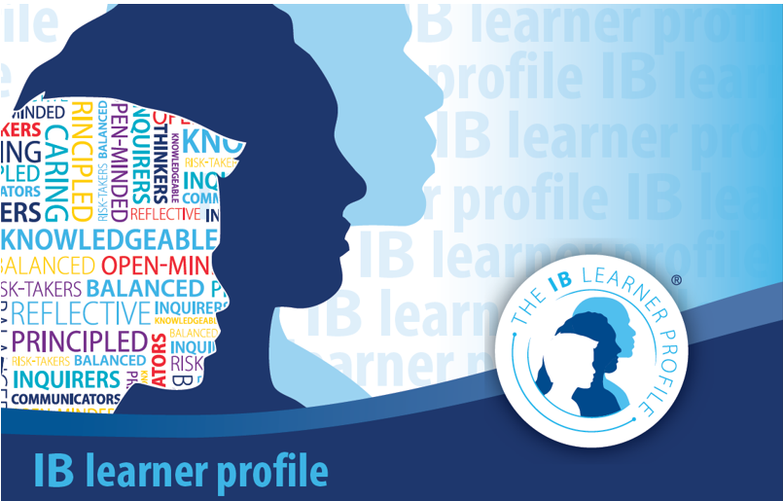

Please complete this application and return to:

IB Coordinator
Mountain Creek State High School
P.O. Box 827
MOOLOOLABA QLD 4557

Applications must be received by Friday, 26 November, 2021 (end of Week 8)

Student (applicant) Name: Current School:
Current Year Level (in 2019):

Date of Birth: Gender: (please circle) Male / Female Parent/Guardian Name/s:
Address: Suburb: Postcode: Phone Number: (Home) (Mobile):
E-mail address (Parent/Guardian):

Brothers or Sisters currently attending Mountain Creek State High School:

Name: Form Class: Name: Form Class: Name: Form Class:

- ACADEMIC ACHIEVEMENT and CONDUCT

Please attach a copy of your most recent report.

- IB SPIRIT

Outline how you demonstrate the MCSHS-IB Spirit of “I Believe, I Belong, I Become” exemplifying international-mindedness, community service and global citizenship, a holistic growth mindset, intellectual risk-taking and multi-disciplinary creativity e.g. CAS activities, extra and co-curricula activities, community and school service, the IB Learner Profile, sense of internationalism, integrity.

- ADDITIONAL INFORMATION

If you wish the P&C Association to consider any additional information e.g. financial – please outline this information below:

- CONFIRMATION

In submitting this form, I declare that the information on this form and in the accompanying documents and statements is complete and correct to the best of my knowledge. If any of the information is found to be false or misleading, I accept that MCSHS may cancel any scholarship that might be awarded to me on the basis of this application.

Applicant Name: ______________________________ Signature: __________________________

Parent/Guardian Name: __________________________ Signature: __________________________

